Replace and modernize legacy VPN architectures with a cloud-native Zscaler Zero Trust solution to reduce attack surface and lateral movement.

PROJECT DETAILS

Title: Replace and modernize legacy VPN architectures with a cloud-native Zscaler Zero Trust solution to reduce attack surface and lateral movement

In today’s digital environment, organizations face increasingly complex cybersecurity threats, making traditional network security models less effective. Legacy VPN architectures were designed for an older network structure where users accessed resources mainly from within a secure perimeter. However, with the growth of cloud services, remote work, and mobile access, this perimeter-based approach is no longer sufficient. Traditional VPN systems often provide broad network access once a user is authenticated, which can unintentionally increase the risk of cyberattacks and unauthorized lateral movement within the network.
To overcome these limitations, this project focuses on transforming the existing security infrastructure by replacing the legacy VPN system with a modern, cloud-based Zero Trust architecture using Zscaler. The Zero Trust model follows the concept of “never trust, always verify,” where every user and device must be authenticated and continuously validated before gaining access to specific applications.
Unlike traditional VPN connections that allow users to enter the internal network, the Zscaler Zero Trust platform connects users directly to the required applications without exposing the entire network. This approach significantly minimizes the attack surface and prevents potential threats from spreading across systems. Additionally, the solution enhances security visibility, strengthens access control, and ensures safer connectivity for employees working remotely or in hybrid environments.
By implementing this cloud-native security framework, organizations can improve their overall cybersecurity posture while reducing the complexity and maintenance costs associated with legacy VPN infrastructure. This transition also supports scalable and flexible operations, ensuring the organization is better prepared to defend against modern cyber threats and evolving security challenges.

ABSTRACT:

This project focuses on the transformation of a traditional Virtual Private Network (VPN) infrastructure into a modern Zero Trust Network Access (ZTNA) framework using the Zscaler cloud platform. The need for this transformation arises because conventional VPN solutions are no longer effective in addressing the security challenges faced by organizations in today’s digital environment. Traditional VPN systems follow a model where users are granted network access once authentication is completed, which may unintentionally allow attackers to move laterally across systems if a single device or account is compromised.

To address these issues, the proposed solution introduces a Zero Trust architecture that operates on the principle of strict identity verification and controlled application access. The Zscaler Zero Trust Exchange provides a cloud-based security platform that connects users directly to specific applications instead of allowing them to access the entire corporate network. This method ensures that only authorized users can reach the resources they need, while keeping the rest of the network hidden and protected from external threats.

By implementing this cloud-native solution, organizations can significantly reduce the risk of cyberattacks and unauthorized access. Additionally, the system enhances performance by directing user traffic through Zscaler’s globally distributed cloud infrastructure, enabling secure and efficient connectivity for employees working from various locations. This approach supports modern work environments where remote and hybrid working models are increasingly common.

The implementation of this project is expected to strengthen the organization’s overall security framework by minimizing vulnerabilities and preventing lateral threat movement. It will also simplify security management through a centralized cloud platform, reduce operational complexity, and improve scalability. Overall, this transition to a Zero Trust architecture will provide a more secure, flexible, and future-ready networking solution for the organization.

USE CASES:

Scenario 1: Third-Party Vendor Access to Finance Application
In this situation, an external auditing professional requires short-term access to the university’s finance management application to complete financial verification tasks. Instead of providing a full VPN connection, the Zscaler Private Access (ZPA) solution offers restricted, application-level access for a limited time period. The auditor authenticates through the organization’s identity management system and is only permitted to interact with the required finance application. Access to other internal systems remains completely blocked.

Output:
- User authentication confirmed (External_Auditor_Group)
- Temporary access policy applied (valid for 7 days)
- Access allowed only to the Finance Application
- Other internal resources remain inaccessible

Scenario 2: Research Assistant Access to High-Performance Computing Cluster
A postgraduate research assistant needs to access a high-performance computing (HPC) cluster located within the university’s internal network to execute research scripts and perform data analysis. Through ZPA, the user can establish a secure connection directly to the computing cluster without opening SSH ports to the public internet or creating a full VPN tunnel. This ensures that the connection is secure and limited only to the required system.

Output:
- User authentication verified (Research_Assistant_Group)
- Access granted only for SSH protocol
- Secure micro-connection created to the HPC Cluster
- No access to other network segments

Scenario 3: Administrative Staff Access to Internal File Server
An administrative staff member working from a remote campus office needs to access an internal file server that stores confidential student data. ZPA validates the identity of the user and checks the device security status before allowing the connection. Once verified, the system allows access only to the required file server while monitoring the data flow to prevent any unauthorized data transfer.

Output:
- User authentication confirmed (Admin_Staff_Group)
- Device security compliance verified (encryption and updates enabled)
- Controlled file permissions applied (Read/Write access)
- Data Loss Prevention (DLP) monitoring enabled

Scenario 4: IT Administrator Secure Access to Server Management Interfaces
A system administrator must remotely manage important Windows servers located in the data center. Using ZPA, the administrator connects directly to the server through a secure RDP session without exposing the management interface to the internet. Additionally, the system records administrative activities for monitoring and auditing purposes.

Output:
- User identity verified (IT_Admin_Group)
- Privileged access approval process activated
- Administrative sessions recorded and monitored
- Secure connection established only to the specified server

Scenario 5: Visiting Professor Access to Library Resources
A visiting professor from another institution requires temporary access to the university’s digital library archives hosted on an internal server. ZPA allows controlled and time-limited access to the specific library application without granting access to the internal network, ensuring that other administrative systems remain protected.

Output:
- User authentication confirmed (Visiting_Faculty_Group)
- Temporary access session granted (8-hour limit)
- Access limited to the Library Application Server
- Complete network isolation maintained

STAGE 1

Title of the project:

Replace and modernize legacy VPN architectures with a cloud-native Zscaler Zero Trust solution to reduce attack surface and lateral movement.

Overview:

This project focuses on upgrading the organization’s existing remote access infrastructure by replacing the traditional Virtual Private Network (VPN) system with a modern cloud-based Zero Trust security framework provided by Zscaler. The main objective of this initiative is to improve network security, reduce vulnerabilities, and provide safer access to internal applications for employees and external users.
Traditional VPN systems were designed using a perimeter-based security model where users are trusted once they successfully connect to the internal network. In this model, users often receive broad network access, which can unintentionally expose sensitive systems and increase the risk of cyber threats. If an attacker gains access through stolen credentials, they may move across different systems within the network, potentially causing large-scale security breaches. In addition, maintaining legacy VPN infrastructure requires continuous monitoring, hardware maintenance, updates, and scaling, which increases operational complexity for IT teams.
To overcome these challenges, this project introduces a Zero Trust architecture using Zscaler Private Access (ZPA). The Zero Trust model follows the principle of “never trust, always verify,” where every user and device must be authenticated and validated before accessing any resource. Instead of allowing users to connect directly to the internal network, ZPA connects users only to the specific applications they are authorized to use.
One of the major advantages of this architecture is that internal applications remain hidden from the public internet. By removing direct exposure of application servers, ports, and IP addresses, the system significantly reduces the potential attack surface. When a user attempts to access an application, ZPA verifies the user's identity, device status, and security policies through integration with identity management systems such as Azure Active Directory. Once verification is complete, a secure encrypted connection is created directly between the user and the required application.
This method ensures that users do not gain visibility of the entire network, which prevents unauthorized exploration or movement within the system. As a result, even if an account becomes compromised, attackers cannot easily access other internal resources.
The implementation of this project is expected to provide multiple benefits to the organization. It will strengthen the overall cybersecurity framework by minimizing security risks and preventing lateral threat movement. Additionally, the cloud-native infrastructure improves performance by allowing users to connect directly to applications without routing traffic through centralized data centers. This approach also simplifies network management by replacing complex VPN hardware with a scalable and centralized cloud-based platform.
Overall, this modernization initiative will help the organization build a more secure, efficient, and flexible access environment that supports modern work patterns such as remote and hybrid work while ensuring strong protection against evolving cyber threats.

List of Vulnerability Table:

Practice Website: https://demo.testfire.net/

S.NO | VULNERABILITY NAME | CWE - No
1 | Improper Sanitization of File Paths | CWE-284: Improper Access Control
2 | Invalid Certificate | CWE-295: Improper Certificate Validation
3 | Missing X-Frame  Options Header | CWE-1021: Improper Restriction of Rendered UI Layers or Frames
4 | X-Content-Type-Options Header Missing | CWE-918: Server-Side Request Forgery (SSRF)
5 | Ajax API shows JSONP not disabled by default | CWE-937 / CWE-1035: Using Components with Known Vulnerabilities
6 | API Vulnerability | CWE-20: Improper Input Validation
7 | Improper API Filtration (Cross-Site Scripting) | CWE-79: Improper Neutralization of Input During Web Page Generation
8 | Denial of Service | CWE-400: Uncontrolled Resource Consumption
9 | TLS Version 1.0 Protocol Detection | CWE-327: Use of a Broken or Risky Cryptographic Algorithm
10 | web.config File Information Disclosure | CWE-497: Exposure of Sensitive System Information

Main Website: https://juice-shop.herokuapp.com/

S.NO | VULERABILITY NAME | CWE - No
1 | SSL Medium Strength Cipher Suites Supported (SWEET32) | CWE-200: Exposure of Sensitive Information
2 | Cookie Created Without Secure Flag | CWE-79: Improper Neutralization of Input During Web Page Generation
3 | X-Content-Type-Options Header Missing | CWE-918: Server-Side Request Forgery (SSRF)
4 | Denial of Service | CWE-400: Uncontrolled Resource Consumption
5 | OS Identification | CWE-200: Exposure of Sensitive Information

REPORT

Practice Website: https://demo.testfire.net/

1) Vulnerability Name
Improper Sanitization of File Paths
CWE-284: Improper Access Control
OWASP Category: A01:2021 – Broken Access Control

Description:
This vulnerability occurs when the application does not properly restrict access to files or resources from unauthorized users. Due to improper validation of file paths, attackers may attempt to manipulate file locations and gain access to restricted directories or sensitive files stored on the server.

Business Impact:
If this vulnerability is exploited, attackers may obtain unauthorized access to confidential information or important system files. This can lead to data breaches, exposure of sensitive information, system compromise, and loss of organizational reputation. Proper access control mechanisms must be implemented to prevent such security risks.

Steps to Reproduce:
Practice Website: http://demo.testfire.net/

Reference Link: https://cwe.mitre.org/data/definitions/284.html

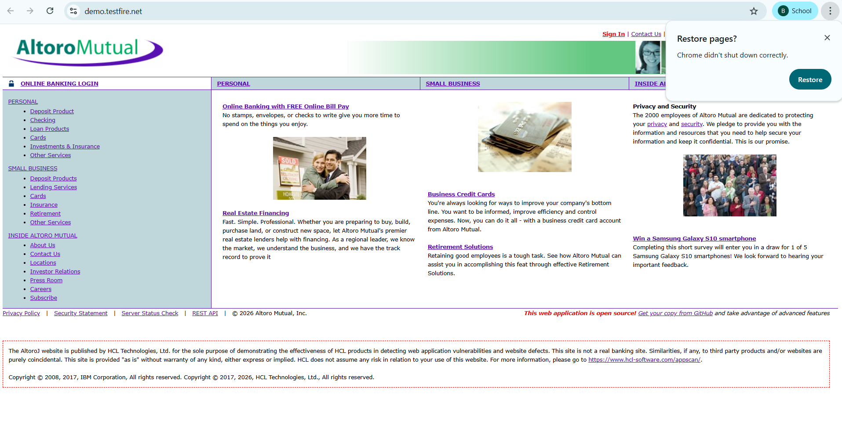

Recommedation:

1. Install Latest Security Updates:
The most important step is to apply the latest security patches released by the Drupal development team. These updates usually resolve known vulnerabilities and improve the overall security of the system.
2. Verify System Configuration:
After updating the system, administrators should carefully review the Drupal configuration settings. Ensure that private files and directories are properly protected and accessible only to authorized users.
3. Perform Regular Security Audits:
Organizations should conduct routine security audits and vulnerability scans to detect potential weaknesses. Regular monitoring helps in identifying security risks before they are exploited.
4. Implement Strong Access Control:
Proper authentication and authorization mechanisms must be enforced. Access permissions should be restricted so that only approved users can view or modify sensitive files.
5. Reduce Sensitive Data Storage:
It is recommended to store only the necessary information required for the website’s functionality. Limiting sensitive data storage reduces the risk of data exposure during a security breach

2) Vulnerability Name: Invalid Certificate
CWE: CWE-295 – Improper Certificate Validation
OWASP Category: A07:2021 – Identification and Authentication Failures

Description:
An invalid or improperly validated certificate may allow attackers to impersonate a trusted server or website. When a system fails to correctly verify digital certificates, it may unknowingly communicate with a malicious server. This can result in attackers intercepting or altering the data exchanged between the client and server.

Business Impact:
Improper certificate validation can expose the system to several serious security threats. Attackers may perform Man-in-the-Middle (MITM) attacks, where communication between two parties is intercepted and manipulated. This can lead to unauthorized access to confidential data, potential data breaches, and exposure of sensitive information. In some cases, attackers may also distribute malware using fake or compromised digital certificates.
Steps to Reproduce:
SSL Test Reference: https://www.ssllabs.com/ssltest/

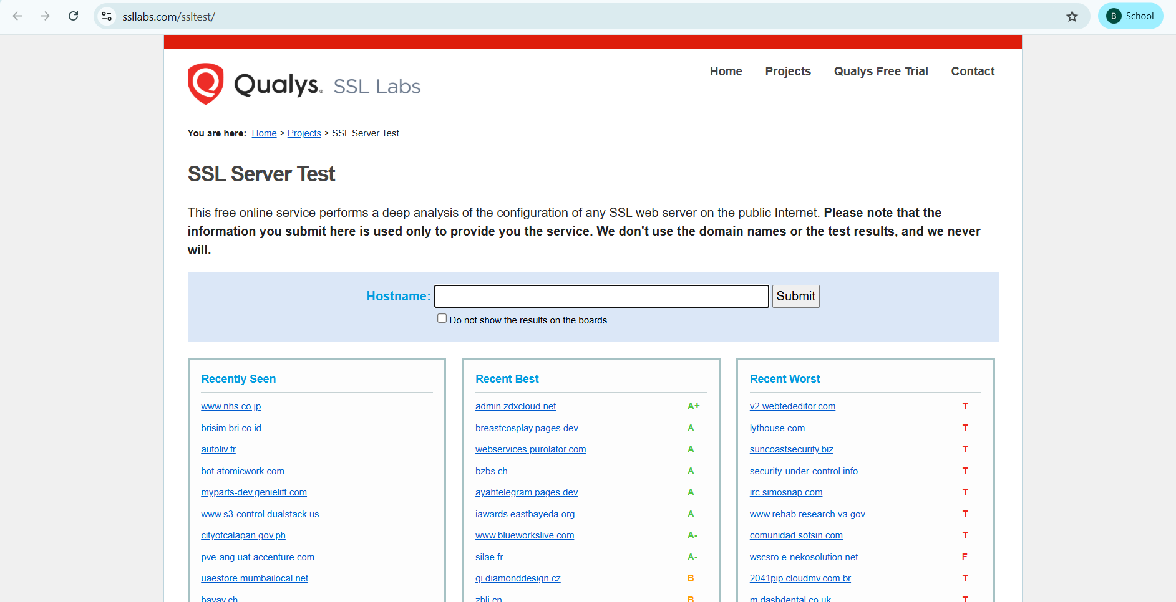

Recommendation:
- Use Reliable Certificate Authorities:
Always ensure that SSL/TLS certificates are obtained from recognized and trusted Certificate Authorities (CAs). Avoid accepting certificates from unknown or unverified sources.
- Implement Proper Certificate Verification:
The application should carefully validate the SSL/TLS certificate before establishing a connection. This includes checking the certificate validity period, issuer information, and matching the domain name.
- Validate the Entire Certificate Chain:
Make sure that the full certificate chain, including the server certificate and intermediate certificates, is verified to confirm that it originates from a trusted root authority.
- Monitor Certificate Revocation:
Check whether the certificate has been revoked by the issuing authority using methods such as Certificate Revocation Lists (CRL) or Online Certificate Status Protocol (OCSP).
- Apply Certificate Pinning:
Implement certificate pinning to ensure that communication occurs only with specific trusted certificates or public keys, reducing the risk of Man-in-the-Middle attacks.
- Maintain Updated Security Components:
Regularly update the application, server software, and security protocols to ensure protection against newly discovered vulnerabilities.
3)Vulnerability Name: Missing X-Frame-Options Header
CWE-1021: Design Improper Restriction of Rendered UI Layers or Frames
OWASP Category: A04:2021-Insecure Design

Description:

A web application should control whether its pages are allowed to be displayed inside frames, iframes, objects, embed, or applet elements. If such restrictions are not implemented, attackers may load the application inside a malicious frame and trick users into performing actions without their knowledge or intention.

Business Impact:

This vulnerability can allow attackers to manipulate the user interface and deceive users into performing unintended actions. As a result, sensitive information may be exposed, fraudulent activities may occur, and user trust in the application may decrease. It can also damage the organization’s reputation and may lead to financial losses.

Vulnerability Path: http://www.itsecgames.com/

Steps to Reproduce:
1.Open the practice website to inspect
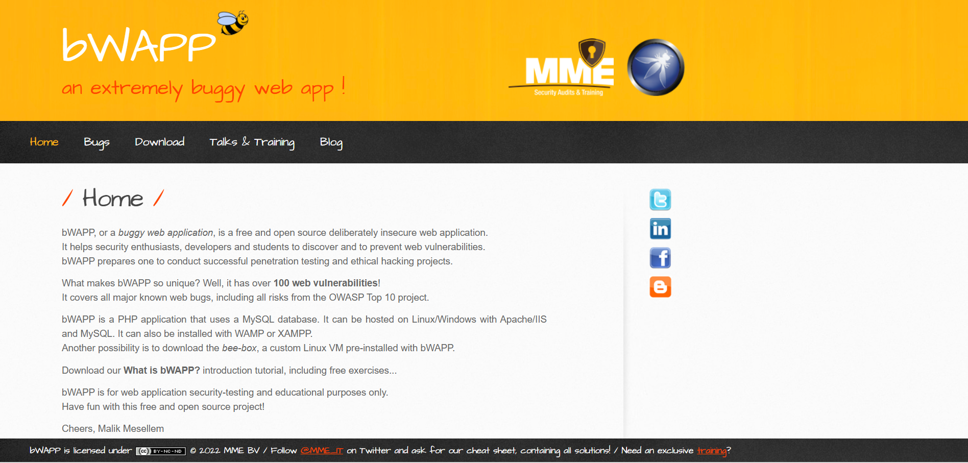
2.Go to network and start capturing using F5 or Ctrl+R
3.Go to html document and see if x-frame-options present in response headers or not
4.If not the absence of this header indicates that the website may not have protection against embedding its content within an iframe on other domains, potentially leaving it vulnerable to clickjacking attacks.
Recommendation:
- Apply Strong UI Access Controls:
Implement proper access control mechanisms to ensure that only authorized users can interact with specific user interface components or frames.
- Strengthen Authentication and Session Handling:
Use secure authentication methods and effective session management techniques to prevent unauthorized users from accessing the application.
- Use Content Security Policy (CSP):
Configure CSP headers to restrict the sources from which content can be loaded. This helps reduce the risk of frame-based attacks such as clickjacking.
- Regularly Update Software and Dependencies:
Ensure that all software components, frameworks, and libraries are kept up to date with the latest security patches to minimize potential vulnerabilities.
4)Vulnerability Name: X-Content-Type Options Header Missing
CWE -918: Server-Side Request Forgery (SSRF)
OWASP Category: A10:2021 – Server-Side Request Forgery (SSRF)
Description:
This vulnerability occurs when a web server accepts a URL or request from another component and attempts to fetch data from that address without properly validating the destination. If proper validation is not implemented, the server may send requests to unintended or malicious locations.
Business Impact:
This issue can lead to several security problems. Attackers may exploit it to access sensitive information that should not be exposed. It can also allow manipulation of content types, which may increase the risk of security breaches, data leakage, or unauthorized system access. In addition, successful exploitation of this vulnerability can damage the organization’s reputation and reduce user trust in the application.

